Experiment 5: Operational Amplifier Application: Electronic Security System

Design: Part 2 of 2

By:

Shawn Keene, Jason Gilman

Supervisor: Saad Muaddi

Data collected on: 10/23/2019

Due: 10/30/2019

ECEN 214-508, Electrical Circuit Theory

Fall 2019

Prof. Scott Miller

**Introduction:**

The purpose of this experiment is to continue to demonstrate an understanding of op amps, IR emitters, photo detectors, and their practical uses in the real world. Along with these units, students will utilize a latch. Latches are units that allow bits to be saved depending on the inputs to the latch. This lab will utilize the units above and the latch to build a security system. The security system will be set off whenever the photo detector is blocked from the IR emitter, and it will continue to be set off until it is reset by the latch.

**Procedure:**

Task 1 of the experiment involved combining every unit from the first lab to make one functional part of the security system. Once the photo detector, non-inverting op amp, and the comparator were connected, students measured the voltage on the output of the comparator to check that the circuit was set up correctly.

Task 2 of the experiment involved constructing the latch. Students used the CD4044B unit, a latch made by Texas Instruments. In order to correctly set up this unit, students followed the diagrams at the bottom of this section

Task 3 was the simplest task and involved setting up the two LEDs that signal whether the security system is tripped or not. Resistors were carefully chosen to make sure no more than 10 mA of current would go through any LED at a time. The minimum resistance calculated was 430 ohms, but due to the limited amount of resistors, 2000 ohm resistors were chosen.

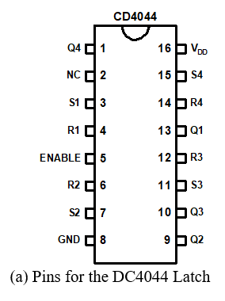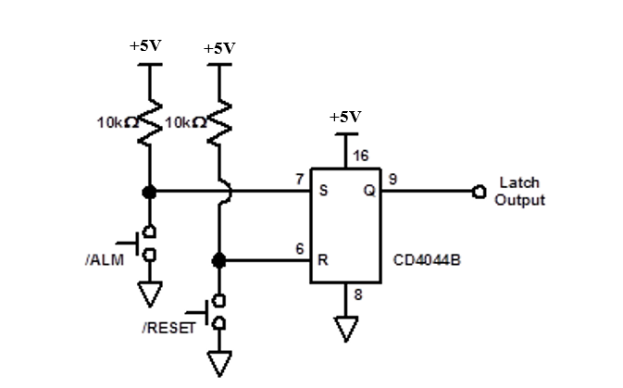

**Data:**

Task 1:

$VOUT_{unobstructed}=4.957 V$

$VOUT_{obstructed}=.175 V$

Task 2:

No measurements

Task 3:

$R_{G}=2000 Ω$

$R_{R}=2000 Ω$

**Calculations:**

There were not many calculations made in this lab. In task 3, two simple measurements had to be made, to calculate the resistance values to lead into the two LEDs. The following equations were used to calculate the resistance:

$R=(V_{in}-V_{drop})/I_{in}$

We wanted there to be no more than 10 mA of current through the LEDs. There was also a .7 V drop across the resistors. Using this information, we constructed the following equations:

$V_{drop}=.7 V$ $I_{in}=10 mA$

$R= (5-.7)/10 mA$

Giving us the inequality to find acceptable resistors:

$R_{G }>= 430 Ω$ $R_{R }>= 430 Ω$

**Discussion:**

The security system designed included several components. The first components were the IR emitter and photo detector. IR emitters turn current into IR light and photodetectors with a resistor turn the light into current and then into voltage. For the emitter a 1000 ohm resistor was used just to be safe and make sure the current did not damage the emitter. For the final design there was a choice between using an op amp and a resistor for the current to voltage converter. A resistor was used to simplify the circuit as it was already complicated. Before this design choice, the emitter and detector were tested completely unobstructed and close together to make sure the voltage was never too high. If the voltage was ever too high, an op amp would have been used which in turn will cause the op amp to become saturated. The resistor value used for the photodetector was 1000 ohms as that provided the greatest difference between unobstructed and obstructed voltages.

Next an amplifier was used to provide a greater difference between unobstructed and obstructed voltages. The design required a noninverting amplifier as an inverting amplifier would cause the comparator to never work properly. As the photodetectors voltage was more than enough to make the comparator work, an amplifying value of one was used. If a user of the security system ever had any voltage problems, the amplifiers resistances could be changed to increase the gain. In order to have as close to a one ratio gain, a 100 ohm resistor and 360k ohm resistor was used in order to make the gain 1.000278

After the amplifier was correctly setup, the comparator followed. The comparator works by comparing a reference voltage with an input voltage. If the voltage is below the reference voltage it will give a low voltage, and if it is above it will give a high voltage. The reference voltage chosen was 2.5 V as it was the exact halfway point between an unobstructed detector and an obstructed detector. If the security system needs to be more sensitive, then the reference voltage could be raised. Along with this, the reference voltage was connected to the negative terminal. If the reference voltage was connected to the positive terminal, the opposite value wanted would be obtained.

**Conclusion:**

This lab allowed students to combine various smaller circuits to create an overall electronic system. There were a few mistakes when designing the circuit that needed to be addressed by measuring the voltage across various points in the system. Using the debugging method previously described, the electronic system was successfully created. There were no false alarms or missed detections, although a scenario where the grounding “reset” jumper cable could accidentally become activated is possible. The emitter and detector could be placed a few inches apart, although our implementation of the system only allowed for limited testing of this statistic.